Graduate Women (WA) Research Presentation Evening May 14th 2018

Once again the 6 six scholarship and bursary winners gave an entertaining report of their various research projects to an appreciative audience. From testing bee DNA in the south-west of WA to exploring ethnobotanical practices in the north-west, from insights into facial recognition to the effect of hand feeding dolphins in the wild, from understanding pain receptors in skin to understanding wave motion in bimodular materials, the evening had something to test everyone’s way of looking at the world around them.

GW WA members want to thank all the people who contribute so much to helping these women achieve success. Our scholarships convenor Trish Todd keeps the process on track with her high standards of organisation, ensuring that the scholarships are well-advertised and the process of sorting and assessing is carried out efficiently. The assessors themselves do a wonderful (and anonymous) job in a short time-frame, with Karen Bothwell in the office keeping track of incoming applications and making sure they are forwarded appropriately.

However it is the generosity of past and current members that enable us to continue to give, and to provide the scholarships. On behalf of our scholars as well as our members, you have our deepest thanks.

Research has been under the pump financially here in Australia, and there has been much discussion in the academic press and the mainstream press about the value of research. How much should we spend for an uncertain outcome seems to be the general gist of the issue, along with a strong push for research with a ‘practical outcome’. But research is not about following, it’s about leading; about growing new industries and opening up new frontiers. As human beings, we have a responsibility to examine ourselves and our place in the in world as consumers and competitors for resources with other species. And perhaps the least appreciated area of research is the striving for knowledge through story and poetry, art and music. These ‘Arts’, as much as any form of education, have been with us since we were consciously aware of ourselves.

The 2018/19 round of scholarship applications is now open. We look forward to again applauding a new group of amazing women.
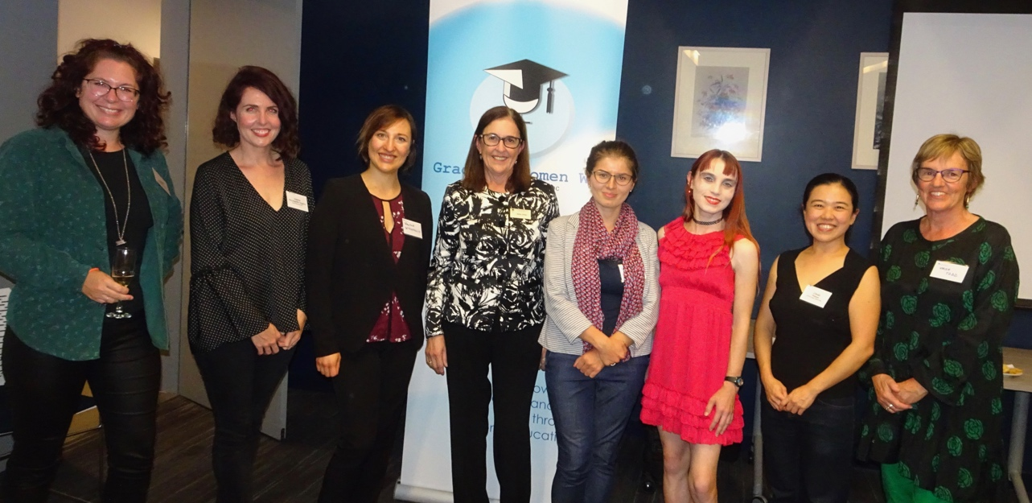
From Left:
India Dilkes-Hall, Laura McLaughlin Engfors, Valeria Senigaglia, Jenny Jones (President GW WA), Maria Kuznetsova, Kit Prendergast Linda Wijaya, Trish Todd (Scholarships Co-ordinator).
Graduate Women (WA) Open Scholarship ($2995.50)
Linda Wijaya commenced her PhD in Psychology at Murdoch University in March 2014 after completing her BSc at Institute Technology Bandung, one of Indonesia’s top universities.

Linda’s research is on complex regional pain syndrome (CPRS), examining the biological underpinnings of CPRS with a goal of improving therapeutic strategies. Linda is seeking funding to enable a final set of experiments on skin cells, building upon her findings. One referee describes her previous studies in the PhD as having been “technically challenging, time-consuming and expensive in terms of laboratory consumables but rewarding in terms of scientific outcomes” and the proposed study “to be ground-breaking”.
At the time her application she had published 6 articles in academic journals, 5 of which have Impact Factors of 3.9, 3.6, 2.8, 2.8 and 4.5 respectively. She had also presented 3 conference papers.

Linda requested $2995.50 for laboratory consumables and she will use the funding for the maintenance of skin cell cultures (This requires a special formulated media) and for the Real Time-PCR (RT-PCR) analysis for gene expression within the skin cells

GWWA Foundation Bursary ($2900)
Valeria Senigaglia enrolled in a PhD in Marine Science at Murdoch University in June 2016. Her previous degrees were completed at the University of Parma and Aberdeen University. At the time of applying for this scholarship Valeria had published three journal articles with IF 2.29, 1.746, 1.665 plus a technical report.

Valeria is researching the ecological consequences of providing food to the dolphins in Bunbury within the context of wildlife tourism. She sought funding to participate in an international conference in her field in Canada. This conference included a workshop on the Bayesian Belief Network, a new methodology to resource management which she is incorporating into her thesis.

GWWA Mary and Elsie Stevens Scholarship ($2,900)
Maria Kuznetsova completed her Bachelor’s degree at Bauman Moscow State Technical University and her Master’s at the University Joseph Fourier in France.

She commenced her PhD in Geomechanics at UWA in March 2015. At the time of applying for this scholarship Maria had published 2 journal articles, Impact Factor 1.329 and 0.634 and had also presented 3 conference papers, one of which received a Best Student paper.

Maria is studying wave propagation problems in biomodular media using analytical and numerical perspectives. This can play an important role in geophysical and exploration applications obtaining additional information on the composition and structure of the earth’s crust.

Her numerical results so far have been published but have raised questions for deeper investigation. Maria sought funding to allow her to spend 3 weeks at a laboratory at the University of Queensland working with experts there.

GWWA Mary Walters Bursary ($3000)
Kit Prendergast commenced her PhD in Environment and Agriculture at Curtin University in June 2016 after completing a combined BA/BSc at UWA with 1st class Hons and with HDs in every subject.

At the time of applying for this scholarship she had published 4 articles: 1 as 3rd author had IF 4.265, 1 was 0.882, 2 were local journals with no available IF. She is studying native bees in urbanised southwest WA aiming to understand what local and landscape factors determine their distribution, abundance and functional composition. Kit is seeking to add on to the approach of morphological identification of specimens with DNA barcoding which provides a much more powerful tool to identify species. The cost associated with sending DNA off and Sanger sequencing of the COI gene is $10 per sample and Kit was seeking funding for 300 samples.

Graduate Women (WA) Jillian Bradshaw Scholarship ($3500)
India Dilkes-Hall enrolled in a PhD in Archaeology at UWA in March 2016. She completed a BA with 1st class Hons in Archaeology at UWA and had a weighted average mark of 81.6% in her BA and 82.1% in her Hons year. At the time of applying for this scholarship India had published two articles, one in a Journal with an IF of 1.268. India’s research is on the history of people and plant relationships in the Kimberley and, by collaborating with Gooniyandi women India was able to learn more about traditional ecological knowledge and ethnobotanical practices and conduct some experiments. The participation of the Gooniyandi women greatly enhanced her research and the use of the funds included payment to the traditional owners as per Guidelines for Ethical Research in Australian Indigenous Studies provided by AIATSIS.

Graduate Women (WA) Joyce Riley Bursary ($2450)
Laura McLaughlin Engfors commenced her PhD in Psychology at UWA in March 2013 after completing her BPsych with 1st class Honours at the University of South Australia for which she received Chancellor’s letters of commendation and a university merit award. In 2017 Laura received an excellence-in-research student award for her publication of a journal article with an IF of 3.358.

Her research seeks to understand why people vary in their ability to recognise people from their faces. She has completed 4 studies in her research. Recently she has been given the opportunity to collaborate with a leading scholar at Wellesley College in Boston who has a large multivariate data set relevant to her work. Laura is seeking funding to undertake an Advanced Structural Equation Modelling course in Analysis of Moment Structures. The course is being offered in Melbourne by Australian Consortium for Social and Political Research Incorporated.

Apart from providing her with the skill-set necessary to analyse the database, the scholarship will also give Laura the opportunity for an important international collaboration.

